Practical no. 5
Name :- Danish Altaf Solkar Enrolment no. :-24111590805
Class :- CO3K – B Subject :- DMS
Aim:- Execute DCL commands to manage database using SQL

QUERY :- CREATE USER Jay IDENTIFIED BY j;
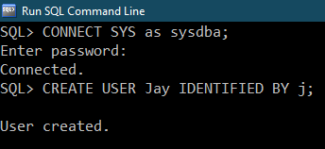

QUERY :- 1) CREATE TABLE Emp(empno NUMBER(3),empname VARCHAR(30),salary NUMBER(6),phoneno NUMBER(10));
2) CREATE TABLE Dept(deptno NUMBER(4),empno NUMBER(3),deptname VARCHAR(30),location VARCHAR(20),jobtype VARCHAR(50));
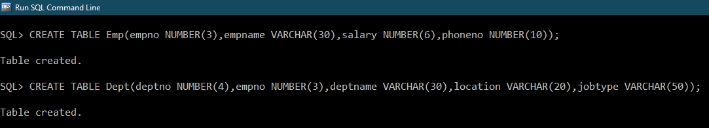

QUERY :- GRANT SELECT, INSERT, UPDATE ON Emp TO Jay;
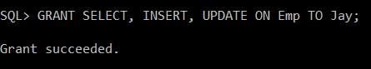

QUERY :- ALTER USER Jay IDENTIFIED BY admin;
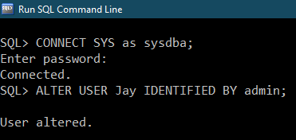

QUERY :- REVOKE SELECT,INSERT ON Emp FROM Jay;
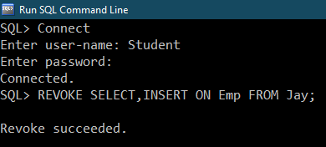

QUERY :- GRANT CREATE TABLE,CREATE VIEW TO Jay;
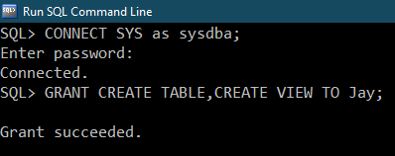

QUERY :- GRANT SELECT, UPDATE(deptno,empno) ON Dept TO Jay;
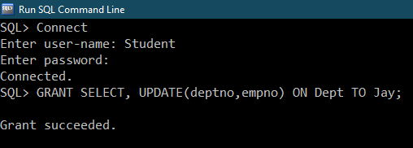

QUERY :- CREATE ROLE emp_pvr;
